Lab – 2 – GIT & GitHub.

GIT
Git is the most used version control system. Git tracks the changes you make to files, so you have a record of what has been done, and you can revert to specific versions should you ever need to. Git also makes collaboration easier, allowing changes by multiple people to all be merged into one source.
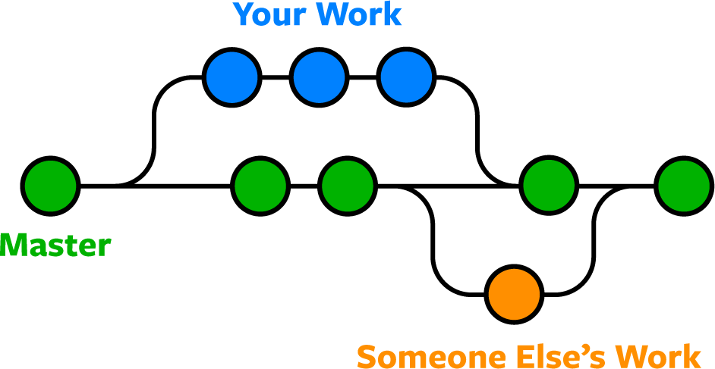

Here are a few Links to learn GIT – What is GIT?
What is GitHub?

We will start with Git basics by making repositories in our local machine. (You can use any Linux VM for this)
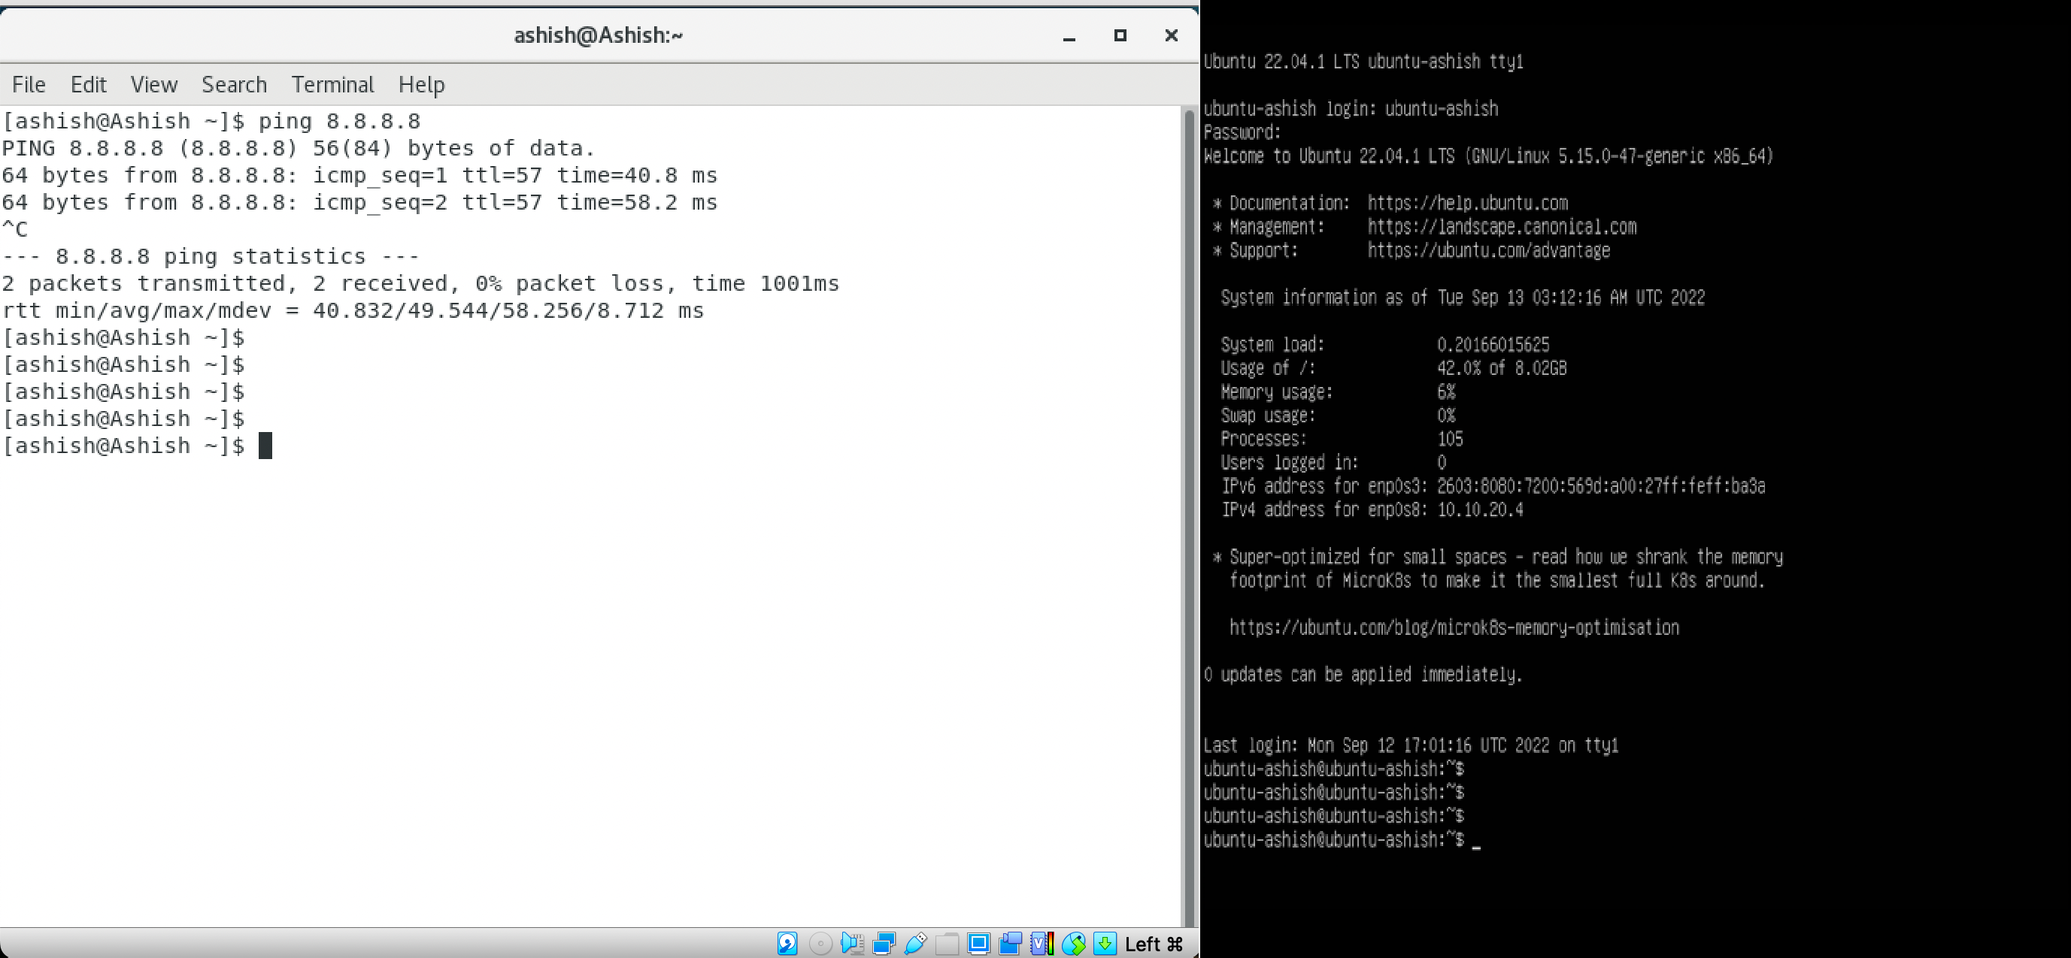
CentOs
Ubuntu

PART 1:
Step 1: Start by installing Git on your machine.
Open Terminal and write the following command to install Git:

sudo apt install git
Verify its installation by checking the version (Add screenshot) (Do not forget to update and upgrade)
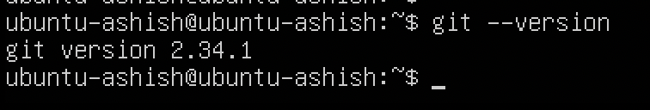
Step 2: Set your username, e-mail, and editor by running the following command: git config --global user.name “your-name”
git config --global user.email “your-email” git config --global core.editor “any-editor”
Run the command to check all the information you set. The output should look like this: (Add screenshot)
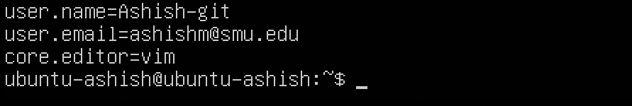

Step 3: Create a directory named: your name-git and navigate into it.

Step 4: Let us start by making our directory a git directory by running the following command: Command – git init Output – This will initialize an empty directory.

Step 5: Which directory git uses to track all changes?
Run the command for it. (Add screenshot)
Run the command to check where git stores its configuration

Step 6: Make a new file named first_file.txt and add the following and save-
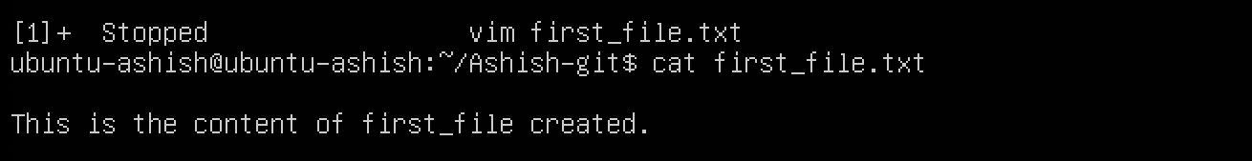

Step 7: Run the command: git status (Add screenshot)

Two theory questions follow:
Q) Explain the output?
Q) Explain the three-tree architecture in Git?

Step 8: For Git to track our changes, let us start by adding these files first Run: git add .
Now next is to commit these changes,
Run: git commit -m “first commit” (Add screenshot)
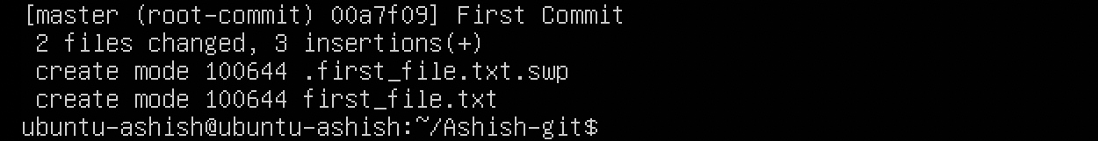

Step 9: Run the command to see check the commit you made. You should see an output like this:
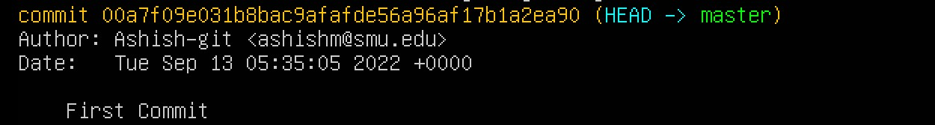

Two theory questions follow:
Q) Explain in detail what is SHA value in Git and what is the SHA value in your previous output?
Q) Explain what HEAD is and what is a master?
Run a command to see and check where the head is pointing (Add screenshot)

PART 2:
Step 1: Make a second file named second_file.txt and add any text to it.
Perform Git Add and commit this file (Add screenshot)

Next: Go back to this file and make some changes. (Write anything like “Hello, the second file”)

Step 2: Run the command to view the change you made.
You should see an output like this: (Add screenshot)
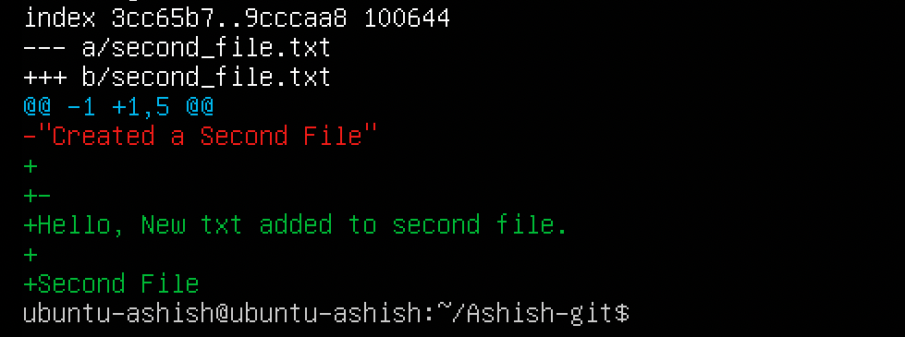

The theory question follows:
Q) Explain the output seen in above SS? – anything written about GIT DIFF command.

Step 3: Go back to the first file you made and make any changes there.

Step 4: Run the command to see the changes you made in both files (Add screenshot)

Step 5: Now run the command to see only the change you made in the first file (Add screenshot)

GitHub
GitHub is a Git repository hosting service, but it adds many of its features. While Git is a command line tool, GitHub provides a Web-based graphical interface. It also provides access control and several collaboration features, such as wikis and basic task management tools for every project.

We will start by creating a GitHub account. Go to the following link and create an account: https://github.com/
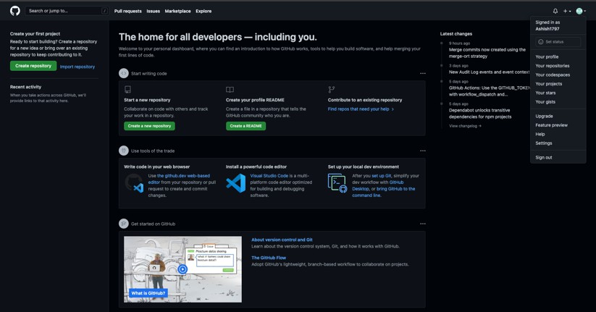

Working Remote
Step 1: Create a new repository of named smu-eets8357-yourname.
Make sure that it is Public and add a README file
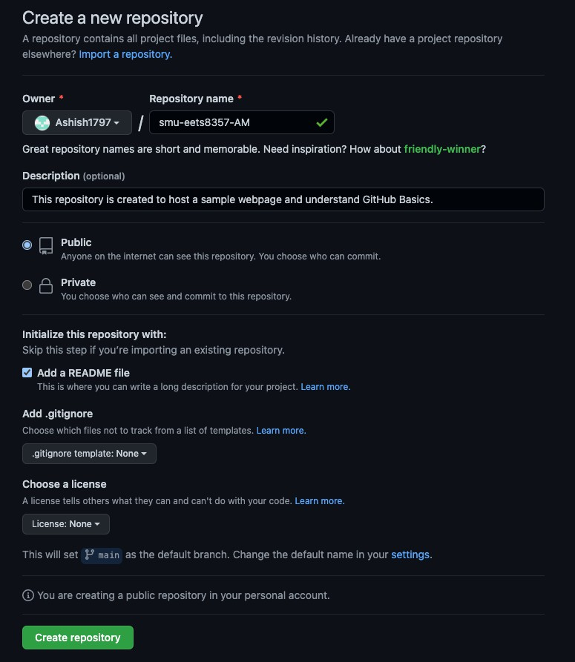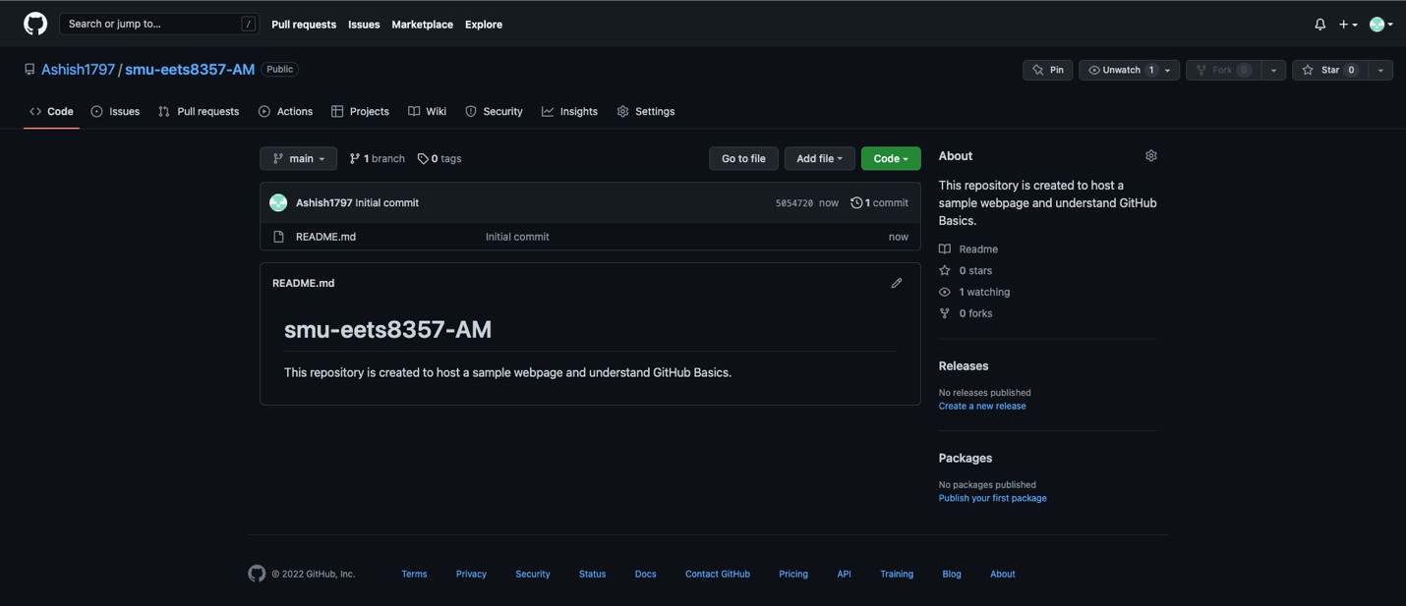

Step 2: Clone this repository in your local machine and navigate into that directory. (Add screenshot)

Step 3: Create a new index.html file such that it should give the following output: (Add screenshots)
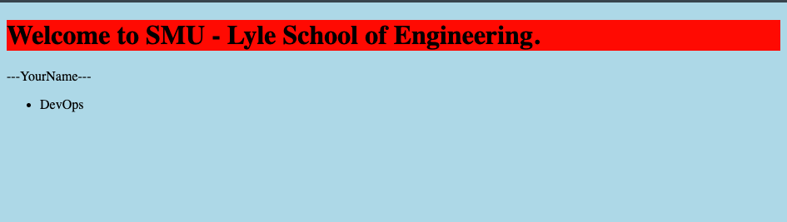
Step 4: Now go back to your HTML file and add an image that would give an output like the following: (Add screenshot)
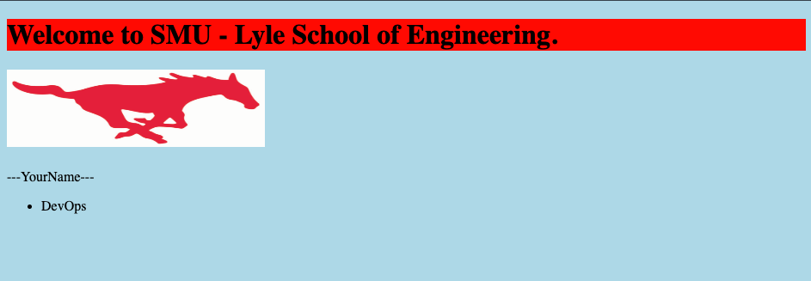

Step 5: Now after committing the previous change, we want to undo it. Revert to the original index file without the image (Add screenshot)

Way to see the HTML file output in terminal itself (optional depends on user)
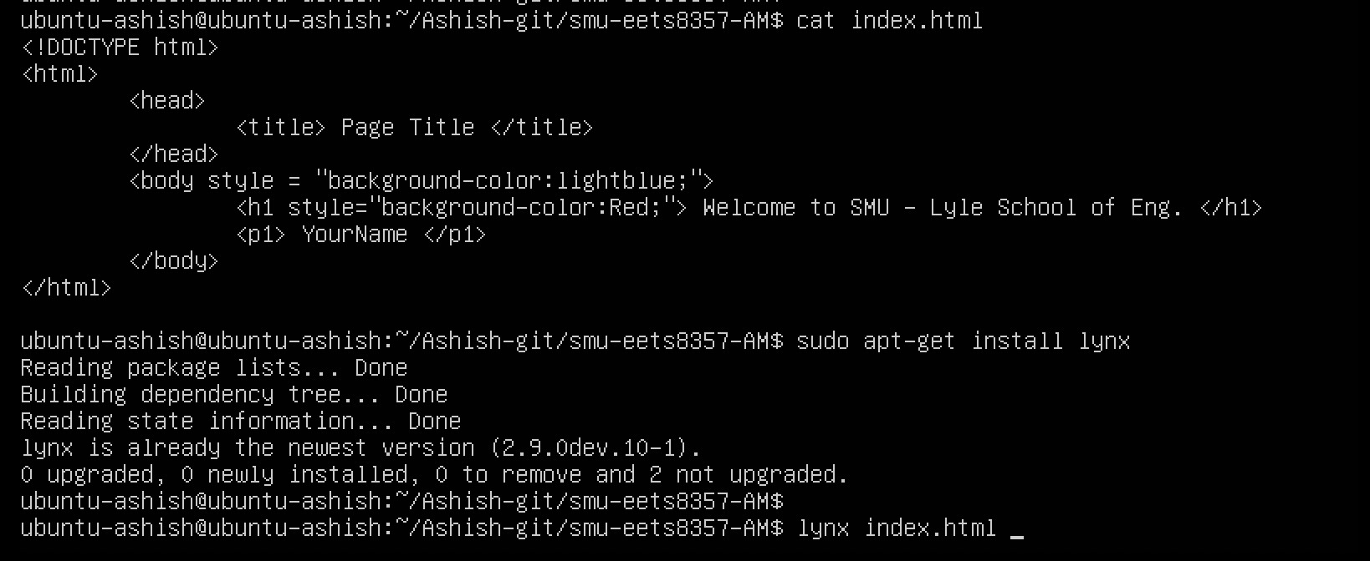

Or use this link to execute html code online. https://www.w3schools.com/html/tryit.asp?filename=tryhtml_intro https://raw.githack.com/ - use this command to change the git URL of HTML to show

HTML CODE: index.html

<!DOCTYPE html>
<html>
<head>
<title> Page Title </title>
</head>
<body style = "Background-Color:lightblue;">
<h1 style = "Background-Color:Red;"> Welcome to SMU - Lyle School of Engineering. </h1>
<h2> <img src = "https://www.smu.edu/-
/media/Site/DevelopmentExternalAffairs/MarketingCommunications/IntegratedMark eting/Logos/Pony,-d-,RwW,-d-,outline,-d-,jpg.jpg?la=en"; width="300" height="90"> </img> </h2>

<p1> ---YourName--- <br> </p1>
<p2> <a href = "https://www.smu.edu"> https://www.smu.edu </a> </p2>
<ul> <li> DevOps </li>
</ul>
</body>
</html>

https://www.youtube.com/watch?v=kHkQnuYzwoo –
use this method as Git changed the Authentication method from 2021.
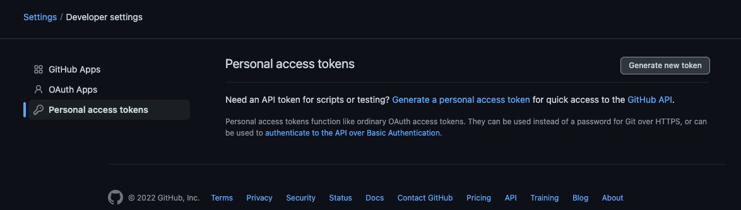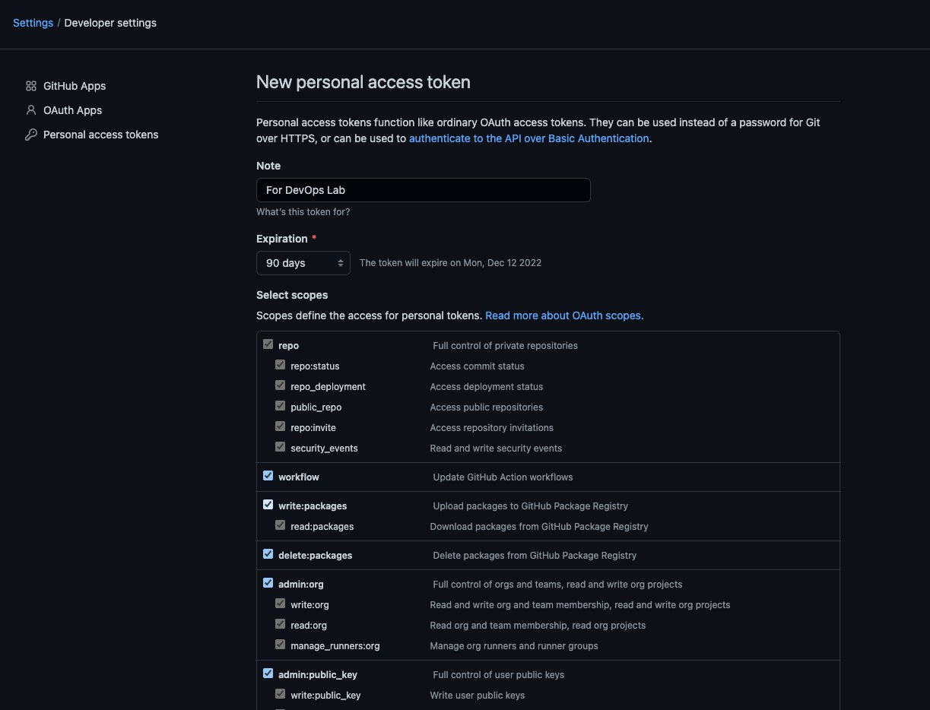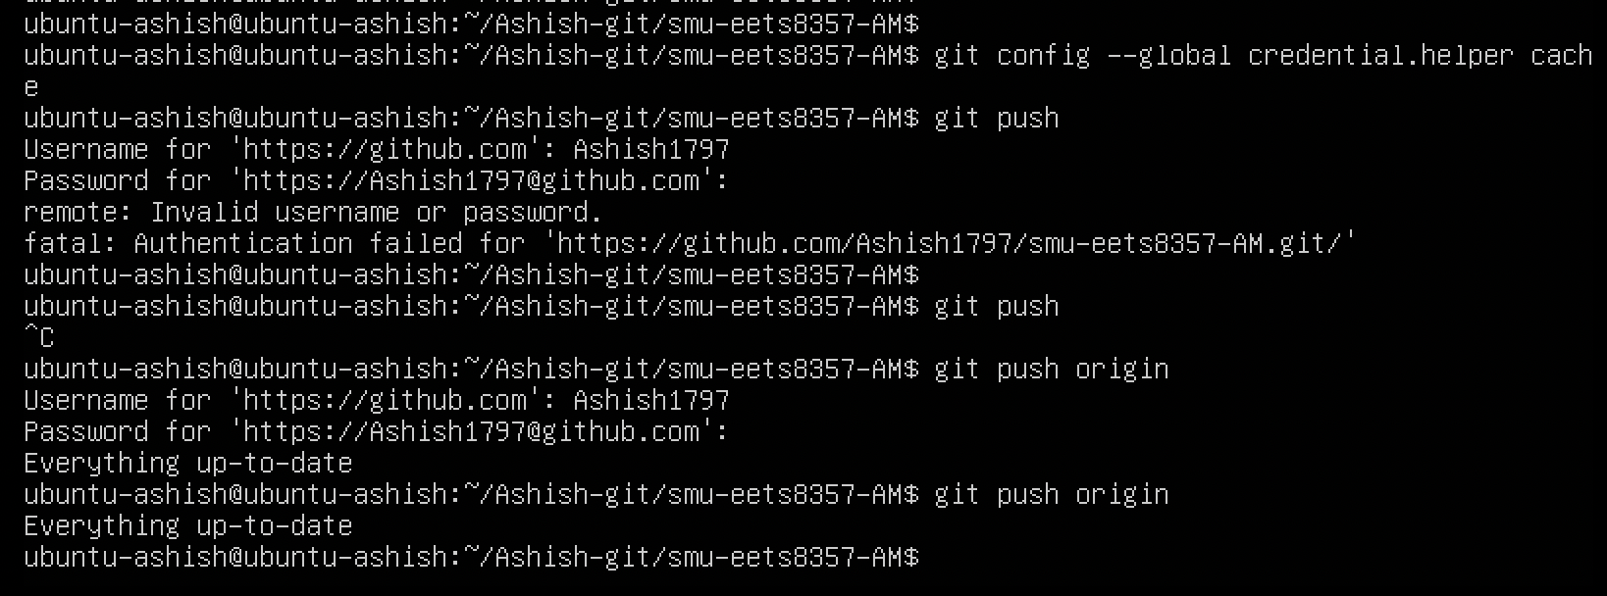

Branching, Merging, And Merge Conflicts.

The theory question follows:
Q) What is a branch, and which is the default branch?
Step 1: Now create a new branch off master named the first_branch
Run the command to check which branch you are in currently (add screenshot) Run the command to check where is the new branch you created (add screenshot)
Run the commands to check where is head pointing for both branches (add screenshot)
Q) Is the head different or the same? Explain your output.
Step 2: Change your branch to the new branch, verify that you have changed it correctly, and push it to your remote repository. (Add screenshots)
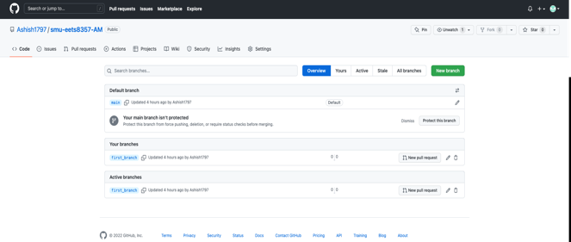

Step 3: Now go to the index.html file and add a link (https://www.smu.edu/) to the index.html (add screenshot)
Check whether the changes you made in your index.html file have been made successfully. (Add screenshot)

Step 4: Now create a new branch named the second_branch and switch to that. (Try doing this with just one command) (add screenshot)
Step 5: Create 2 new HTML pages in the first branch and 1 new HTML page in the second branch. Commit and push it to their respective branches. (Put any text in the HTML file but make sure to write your name in it)
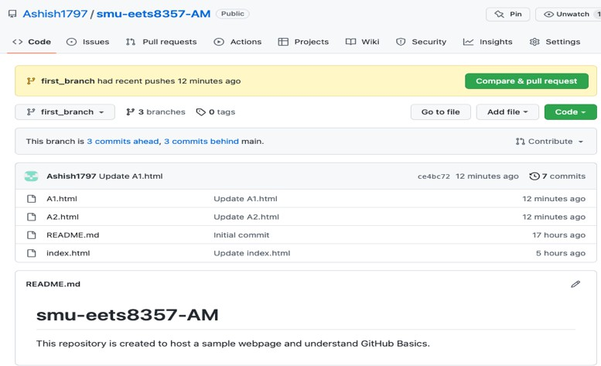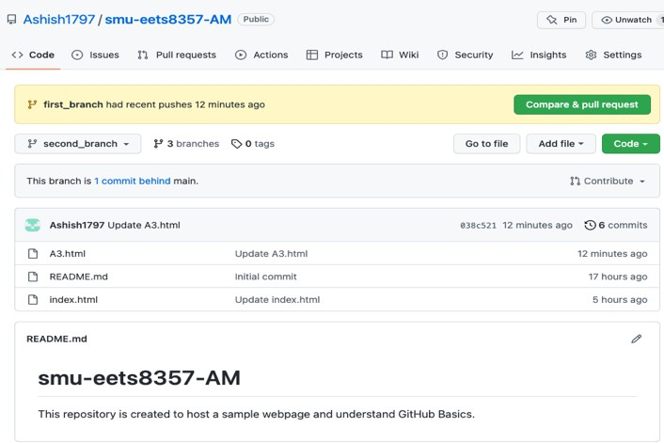

Step 6: Now merge your current branch with a master branch (Add screenshot)
After merging, run the command to check where is head pointing (Add screenshot) Run the command to check if you have successfully merged both branches (Add SS)
Step 7: Switch to your master branch and create a new branch called the third_branch and switch to that. (Add screenshot)

Now edit any one of the files in the repository and commit it in current third_branch.
Switch to the master branch and check for the changes you made. Was it there? If not, explain.
The changes will not be there, as I have not merged the third branch and the master branch

Go to the same file again and make different changes and commit it.

Step 8: Now merge your new branch with the master. Was it successful? (Add screenshot)

Step 9: Explain what merge conflict is and resolve the error you got in the previous step. (Add screenshot)
After resolving, merge again and it should be successful. (Add screenshot) Explain different ways to resolve a merge conflict?
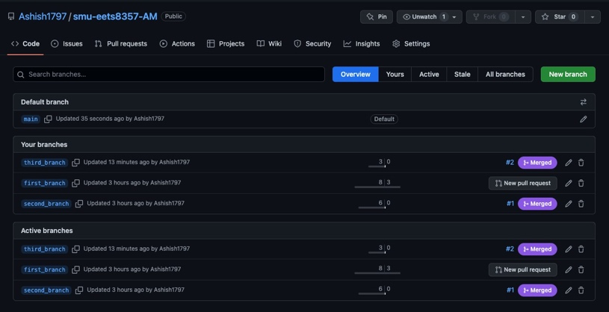

Create a repository with three branches (1, 2, 3), and file-a exists in all three branches. File-b exists in branches 1 and 2, and file-c exists in branch-3.
Explain the behavior/outcome if you switch to any of these branches and then delete the local. git repo.

Paste the whole output of the “git log” after your last task in this Section. Screenshots should have a log of every task you performed.

End of Lab

